

**SECP1513-09 : TEKNOLOGI DAN SISTEM MAKLUMAT**

**(TECHNOLOGY AND INFORMATION SYSTEM)**

**SEMESTER 1, 2024/2025**

**FACULTY OF COMPUTING, UNIVERSITI TEKNOLOGI MALAYSIA**

**GROUP ASSIGNMENT : DESIGN THINKING**

**THEME : BIG DATA AND ARTIFICIAL INTELLIGENT NEW INNOVATION**

**INSTRUCTOR : DR. PANG YEE YONG**

**DATE OF SUBMISSION : 16 JANUARY 2025**

**Table of Contents**

**1.0 INTRODUCTION** 3

**2.0 METHODOLOGY** 4

2.1 Empathy 4

2.2 Define 4

2.3 Ideate 4

2.4 Prototype 4

2.5 Test 4

**3.0 DETAILED DESCRIPTION** 5

3.1 Problem Background 5

3.2 Solution 5

3.3 Team Working 6

**4.0 DESIGN THINKING ASSESSMENT POINTS** 7

**5.0 DESIGN THINKING EVIDENCE** 8

5.1 Emphatize Phase 8

5.2 Define Phase 11

5.3 Ideate Phase 17

5.4 Prototype Phase 18

5.5 Testing Phase 19

**6.0 REFLECTION** 20

**7.0 TASK DISTRIBUTION** 22

1.0 INTRODUCTION

**What is Design Thinking ?**

Design thinking is a collaborative approach that uses iterative testing to create innovative solutions that will resolve complex or unknown problems and provide a satisfying solution for the client. It is a "human centered" approach that involves five core phases which is empathize, define, ideate, prototype, and test. Iterative means that the designer repeatedly cycles through these cores instead of viewing them as a linear path to continuously improve and adapt the solution ensuring it is viable and effective.

Design thinking is important because of its emphasis on user experience, thus ensuring the final solution meets the client’s need and preference. This approach will not overlook the possibility of cutting some unnecessary steps but will also encourage diverse perspectives by thinking outside the box and collaborative effort. Consequently, it reduces the risk and cost by identifying the potential problem in the early stage, resulting in higher user or client satisfaction and loyalty.

In conclusion, design thinking not only guarantees a well rounded solution, it also has the potential to transform industries and society by accelerating the development of innovative solutions. As we begin to understand more, major problems will no longer take a long time to resolve, increasing the likelihood of potential business success.

2.0 METHODOLOGY

2.1 Empathy

To understand something, one must experience it firsthand. By immersing oneself in user daily routine and experience, we gain accurate data to improve our product. For instance, missing or skipping breakfast due to lack of time is very common, especially for university students with tight schedules. This is mostly because they prioritize sleep and save money for lunch and dinner. Little did they know, this can lead to major health problems in the future. Therefore, to grasp the problem, we conducted interviews and an online survey to gain insight.

2.2 Define

Based on the insight gathered in the empathized stage, we found the core problem and the need of our target audience. From there, we establish specific, measurable goal and objective of the project. After that, we created user personas representing different segments based on our target audience, then highlighted the key points and opportunities for improvement.

2.3 Ideate

During the ideation stage, we brainstorm various ideas to address the problem together, exchanging suggestions to bring out all of the possible solutions. The ideas were then grouped into a common theme to identify features for the solution. After that we create rough sketches to visualize it.

2.4 Prototype

At this stage, we make a prototype based on the ideas to explore their viability. We started by coming up with a concept and deciding on the material to use. Based on the feedback, we improve the prototype to become more detailed and realistic.

2.5 Test

In the final stage, we evaluate the effectiveness and usability and check whether we fulfill our criteria. We conducted a user testing session upon completion to gain accurate data. That way we collected on what's working, what doesn't, and what's to improve.

3.0 DETAILED DESCRIPTION

3.1 Problem Background

Based on our research and survey, people face many challenges in meal planning and grocery management, especially students and housewives. They find that meal planning is stressful due to a tight budget and lack of time to prepare it. The need for a solution that offers personalized meal plans that take less time to prepare and budget-friendly options is the key to alleviating this stress.

Budgetary constraints are another significant concern due to inflation. Most people find it hard to stick to a budget while shopping, leading to financial strain and inadequate meal planning. Therefore, a solution that integrates budget-friendly meal options along with grocery lists and store locations can increase efficiency.

Furthermore, accurate portion control and calorie tracking are important to maintain a healthy lifestyle. Most people struggle to diet due to overconsumption or excessive calorie intake. There are also others who suffer from nutrient deficiency because they think eating less food is equal to less calorie intake. Hence, a tool that can guide users on appropriate portion size and calorie intake would make their lives better.

3.2 Solution

After a lot of brainstorming sessions, we decided to address the significant challenge by creating a mobile application, a meal planning and grocery shopping app using AI that integrates with a smart food scale that sends weight data to the app. This way, the user can accurately control portion size and calorie intake while getting the best personalized meal plan based on their diet as well as custom recipe recommendations for those with dietary restrictions.

Furthermore, we also add past purchase detection and price selection that can filter recipes and items based on users budget to ensure they can have wide range budget-friendly meal options while keeping track of their transaction. Additionally, users can use the interactive shopping list and nearest supermarket feature to enhance efficiency and save valuable time.

3.3 Team Working

Before we started the project, we assigned a role for each member to make sure it's fair. We chose the leader, Nurin based on her behavior and qualifications to make sure she will lead the project smoothly. After that we decide on what to create based on the theme given. We decided to make a mobile application and from there we apply five core of design thinking to determine the target user, features for our product, and the impact from creating it.

We use Webex or Google Meet to hold a meeting for discussion and WhatsApp to share important information and documents relating to the project. We also had an interview session with Balqis, a student from UTM. After we collected the data needed, we began to create the prototype and keep improving it based on the feedback until perfection.

Overall, thanks to everyone's cooperation and collaboration, everything went well without a problem.

4.0 DESIGN THINKING ASSESSMENT POINTS

First and foremost, we begin with outlining the objective and other highlighted content to effectively create a design thinking assessment.

Throughout the transition between design thinking phases, our team ensured a seamless progression from one phase to another. Starting with empathizing with the user, we conducted a meeting session to compile all the insight we gained. We then contemplated whether the product we decided on would be beneficial to people and our company in terms of investment or not.

On to the define phase, we analyze the problem statement and assess how serious and impactful it is to figure out the need of our target audience.

Next, we move on to the ideation session where we gather each other's suggestions and opinions. We brainstorm together to bring out-of-the-box ideas to enhance our product's uniqueness. Unrelated or unclear ideas were cut off immediately to avoid wasting time and to increase efficiency. We decide by majority which solution and ideas were the best.

Our team then moved to prototyping, where we refined the product and tested it repeatedly to make sure it fulfilled our user need.

Finally, the mobile application is ready for demonstration. Upon completion, we evaluate the final product and receive feedback from the client and user. In addition, we measure the satisfaction rate to grasp the overall success of the project in meeting its goals.

5.0 DESIGN THINKING EVIDENCE

5.1 Emphatize Phase

To understand user preference, we conducted an online survey through Google Forms and an interview session with a student. This way we can immerse ourselves, gain experience, and know what the challenges are more accurately

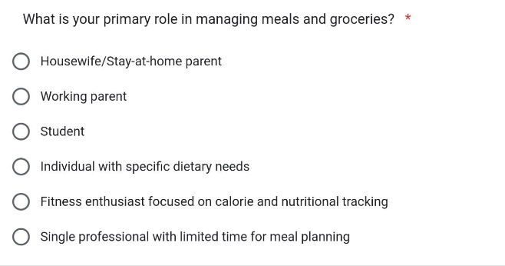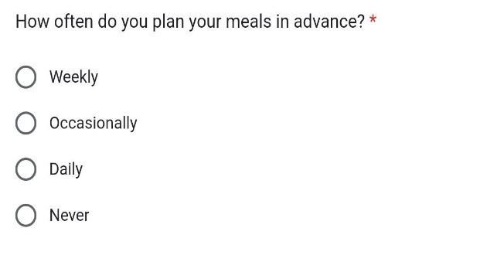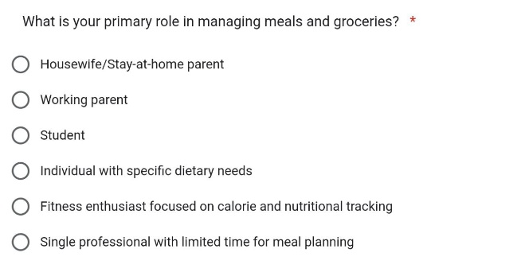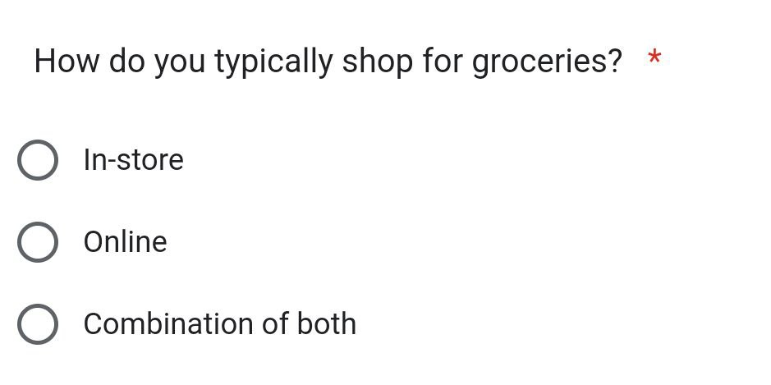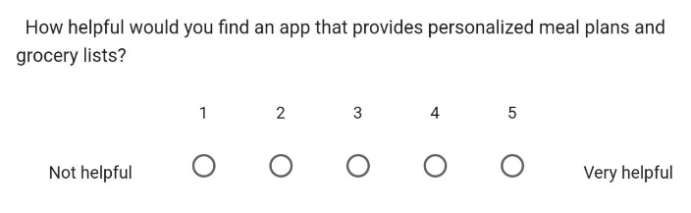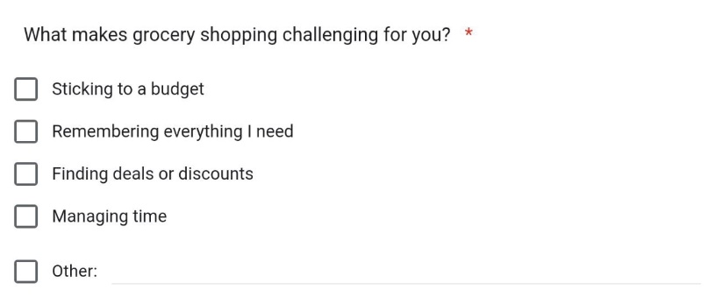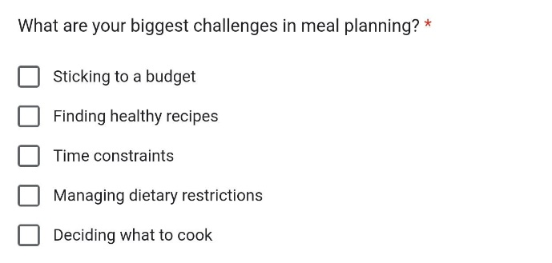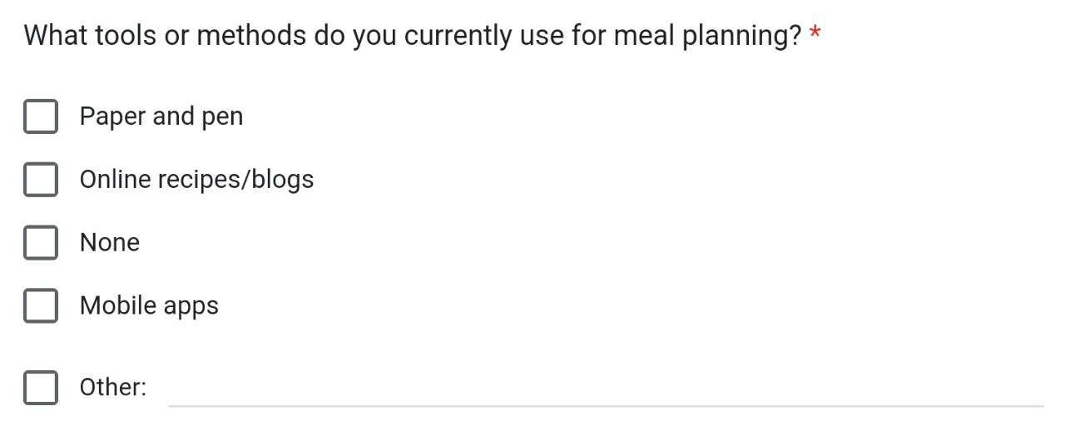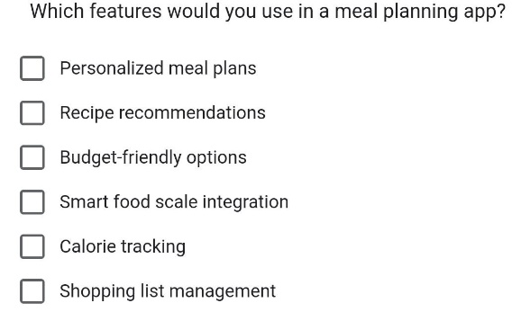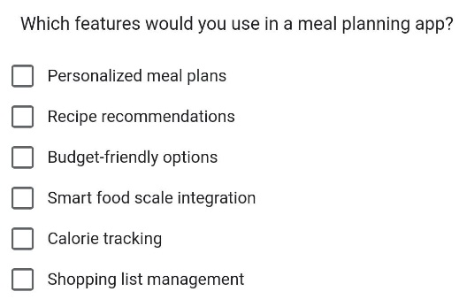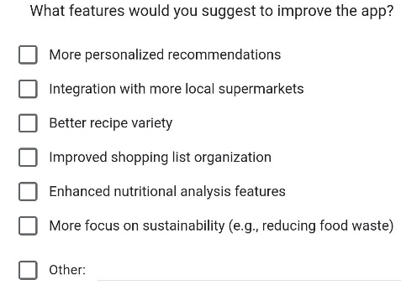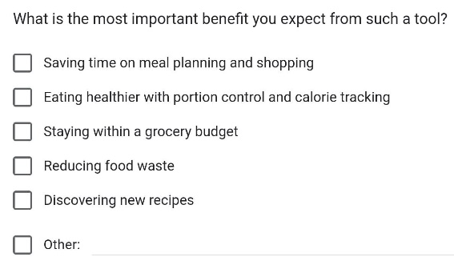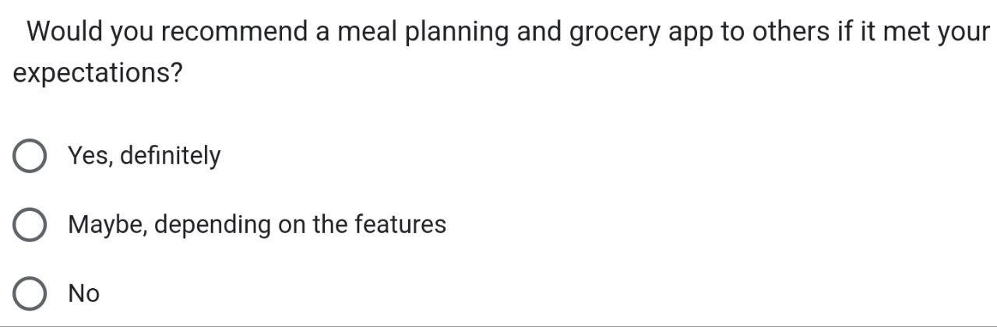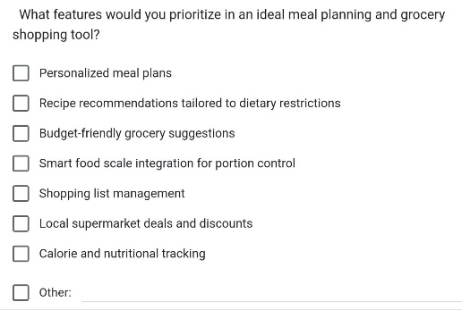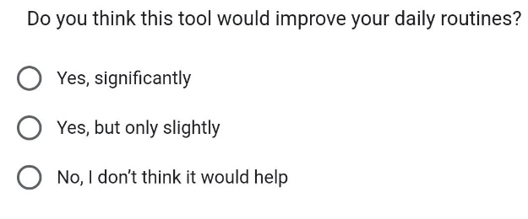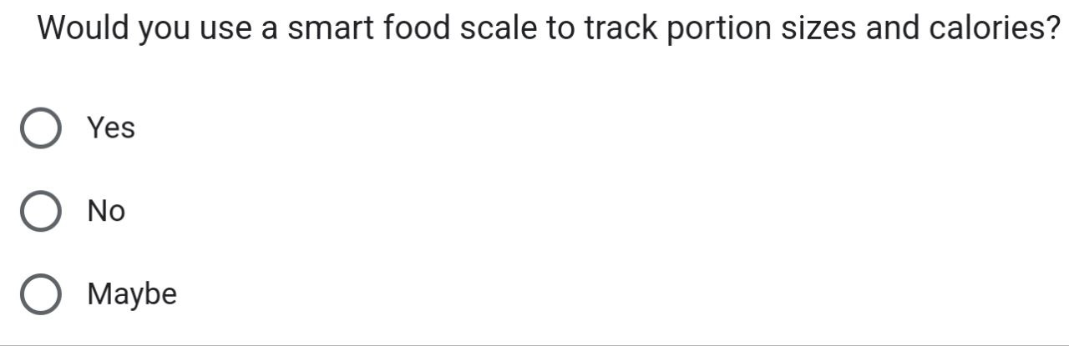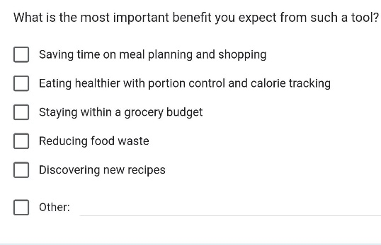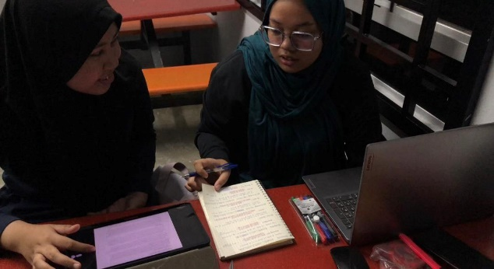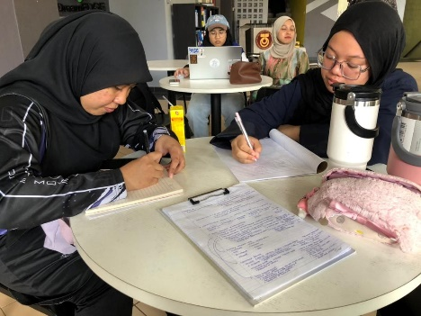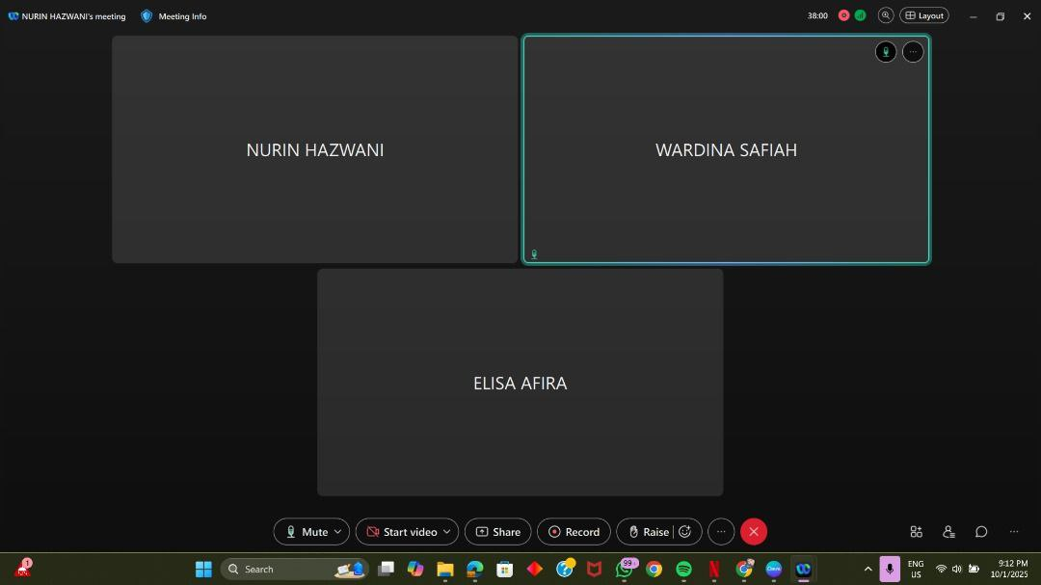

5.2 Define Phase

In the defined phase, we compile all information and organize it into several categories to enhance efficiency. We were able to understand the problem more clearly based on the answers of the survey and interview session.

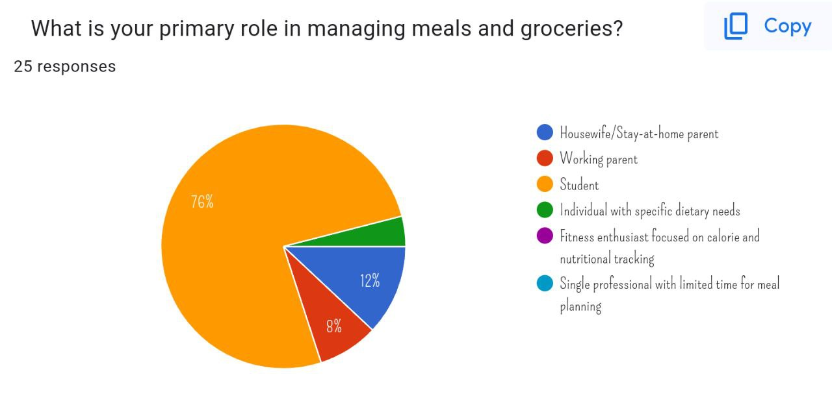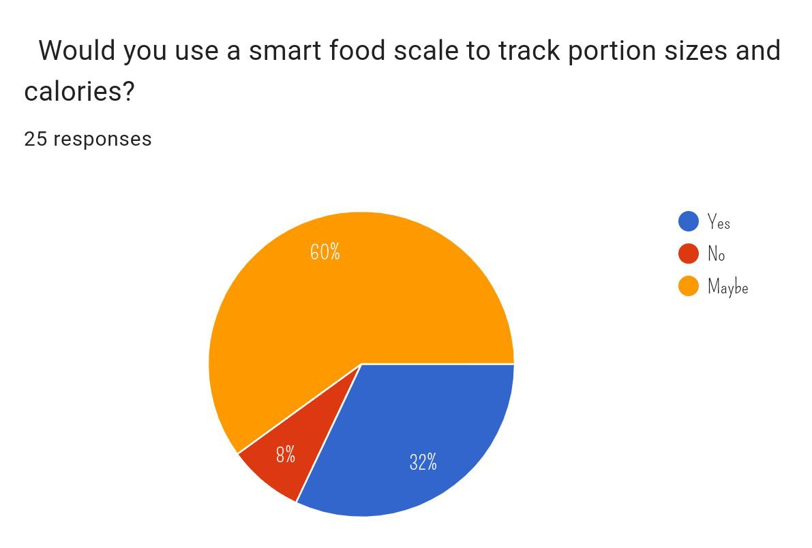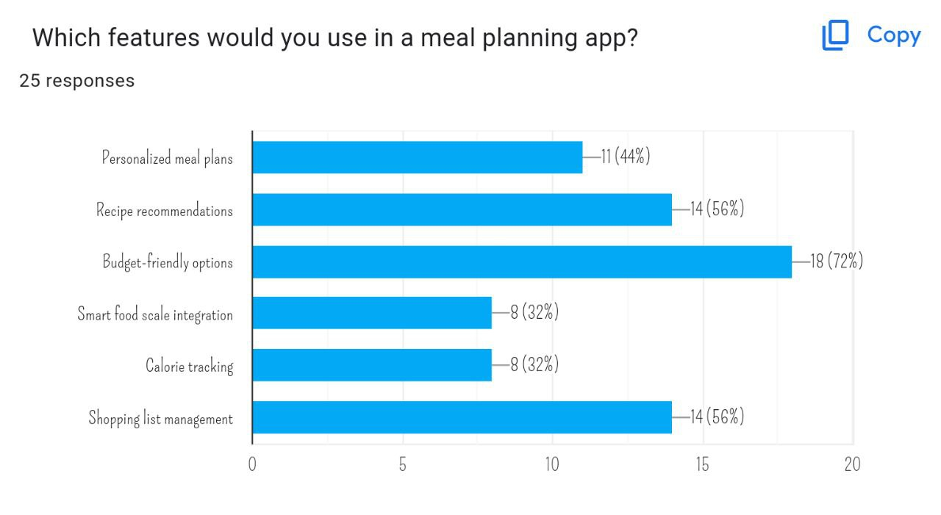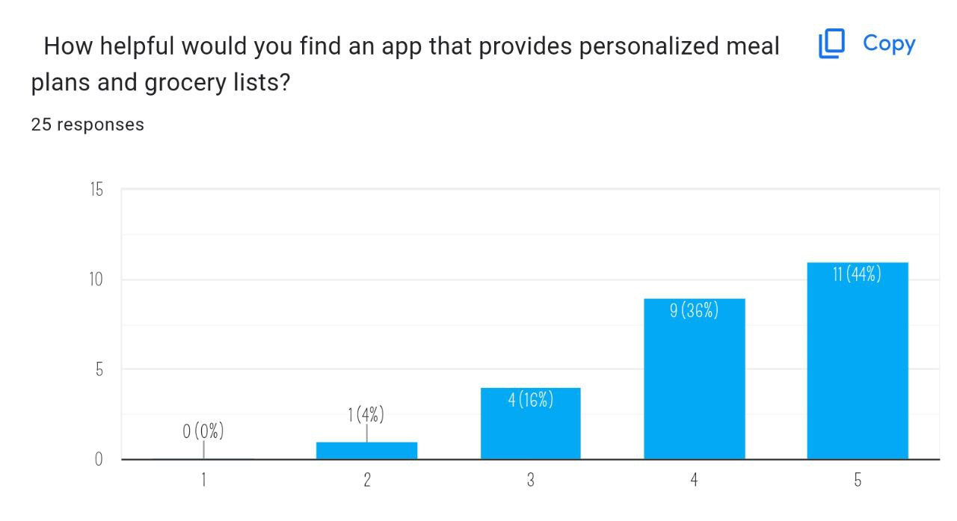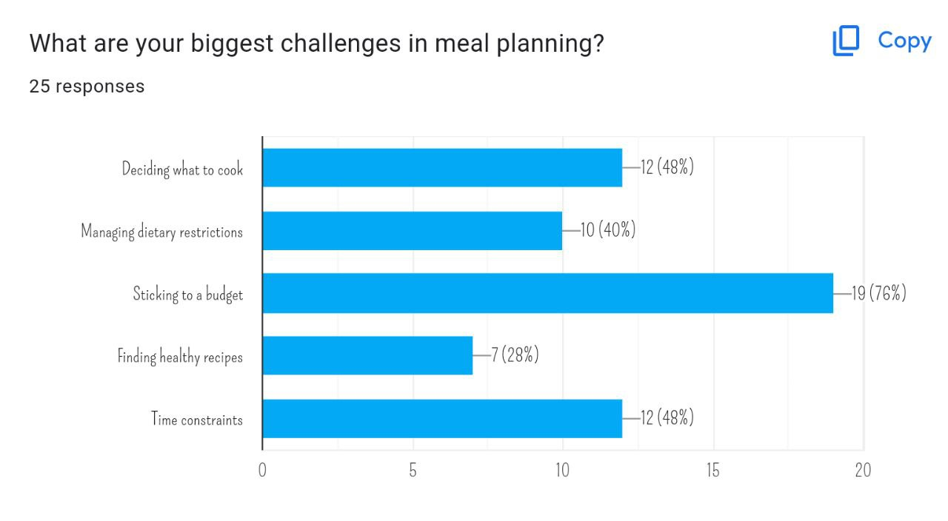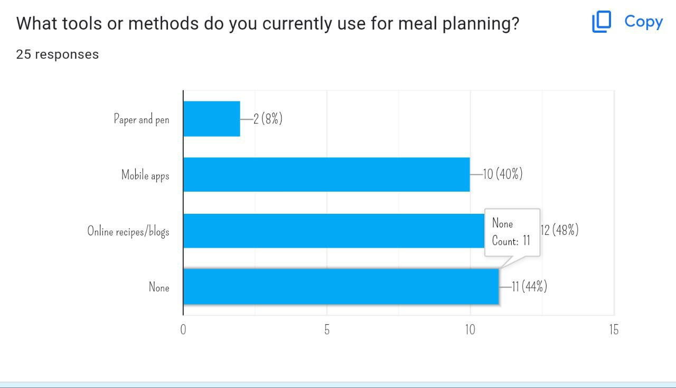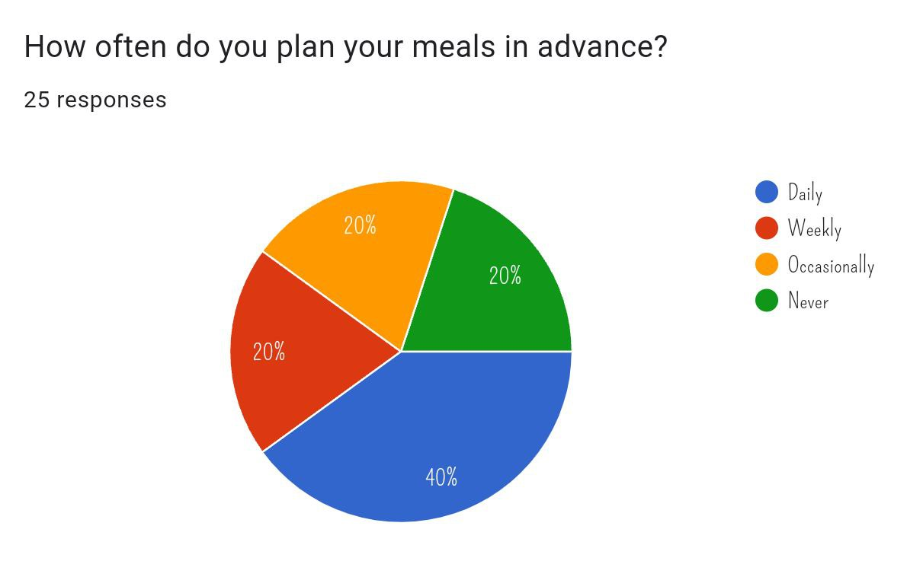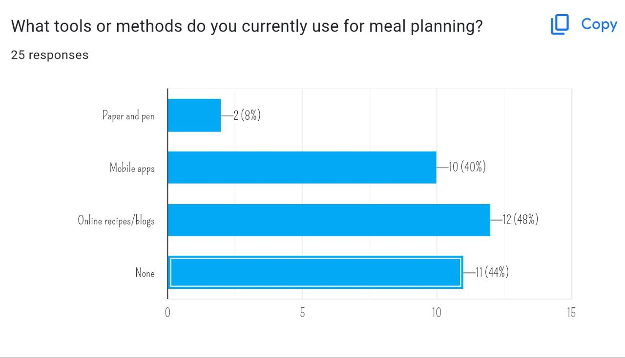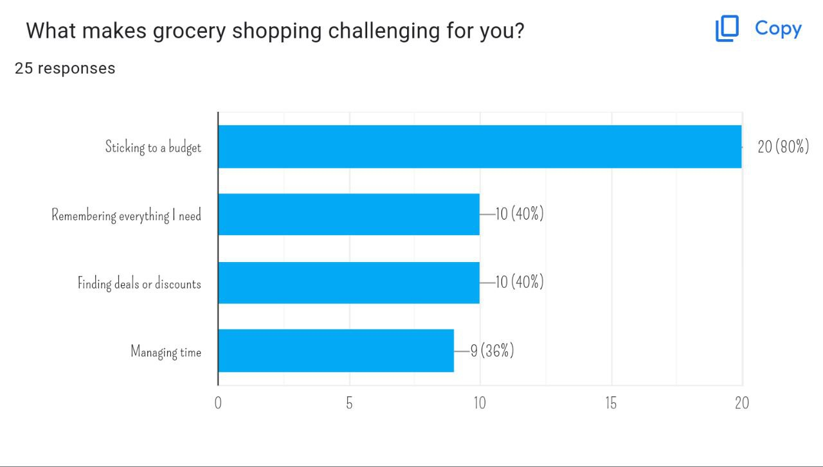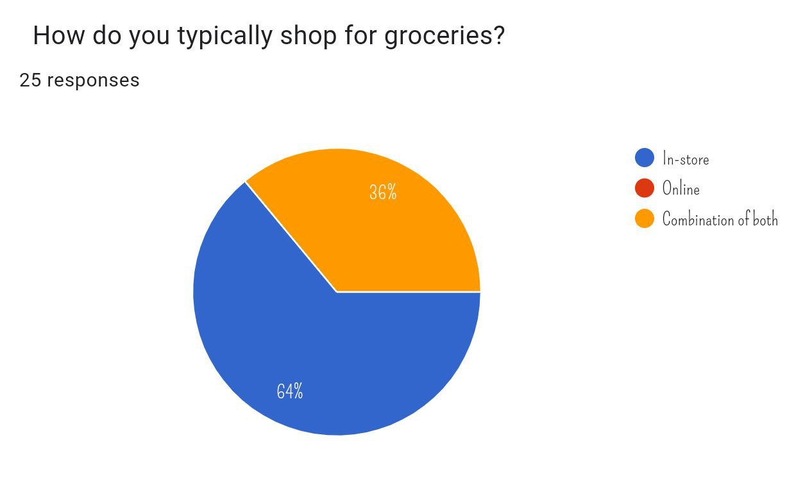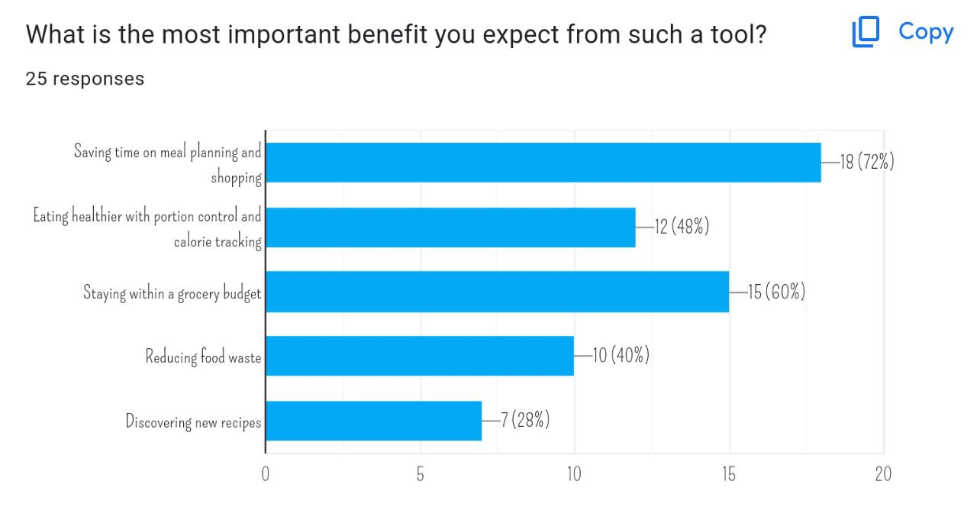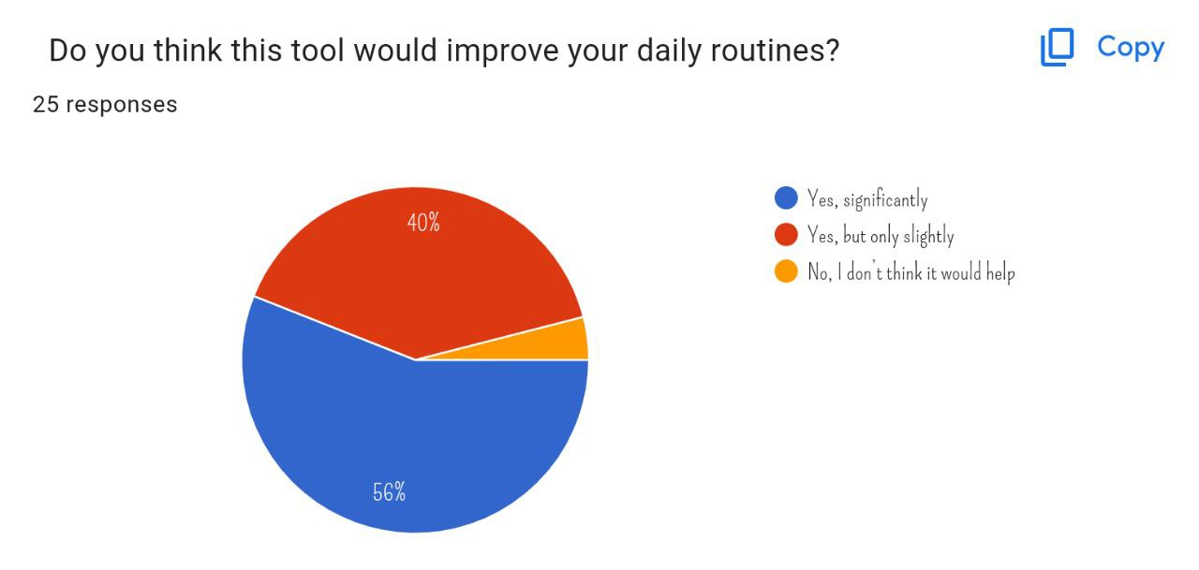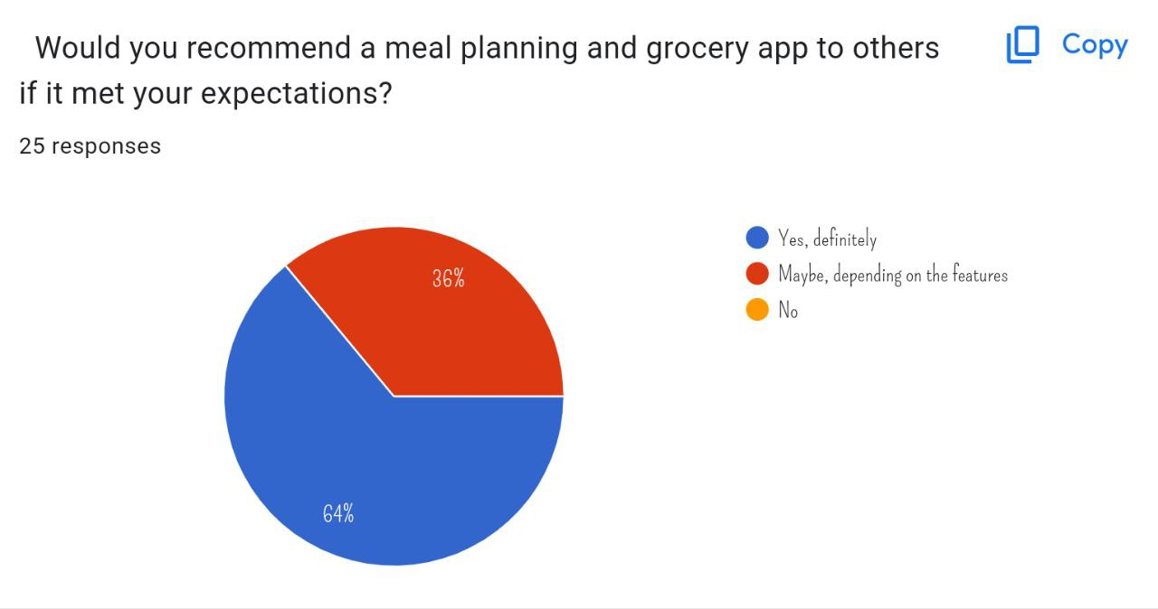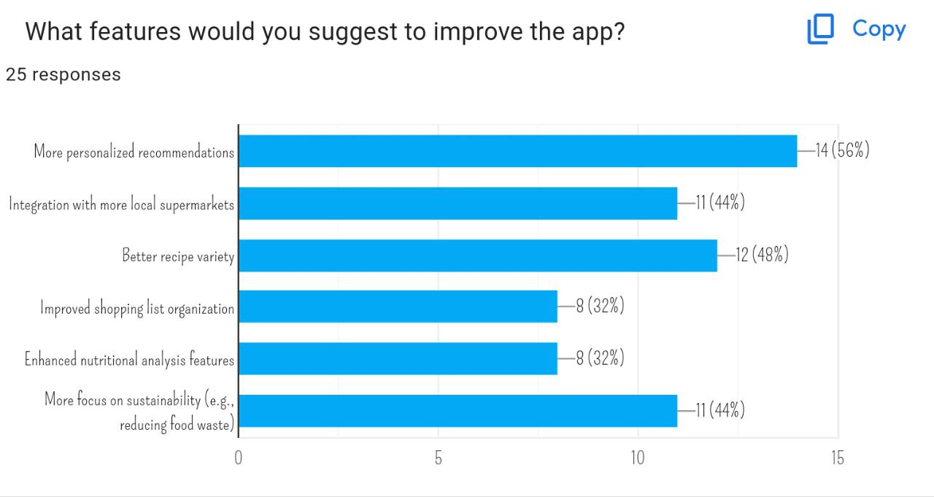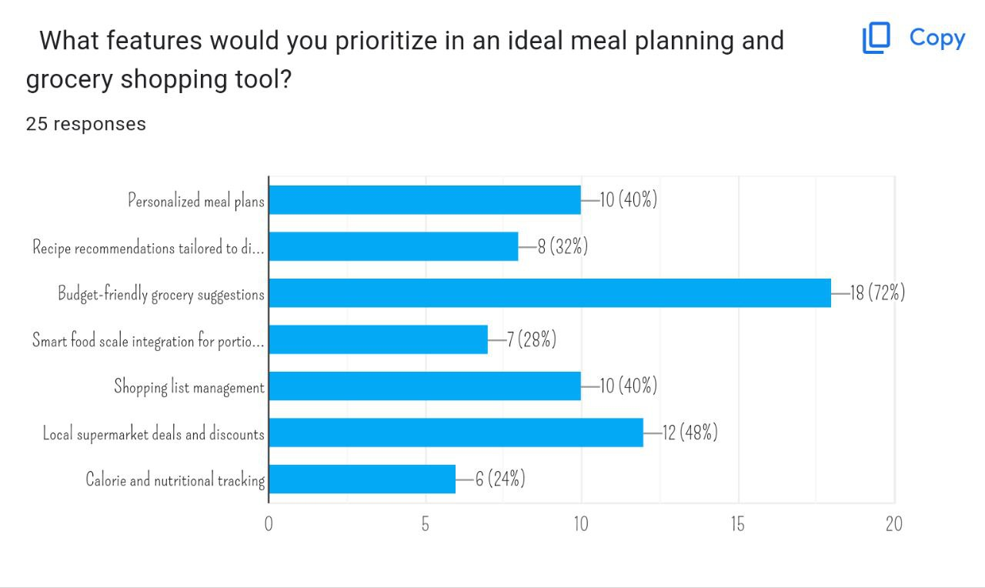

5.3 Ideate Phase

In this phase we come out with our app "MealMate" after a lot of discussion. We also sketch to visualize it easily.

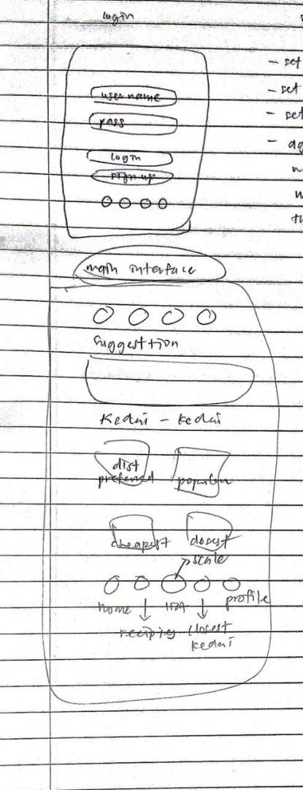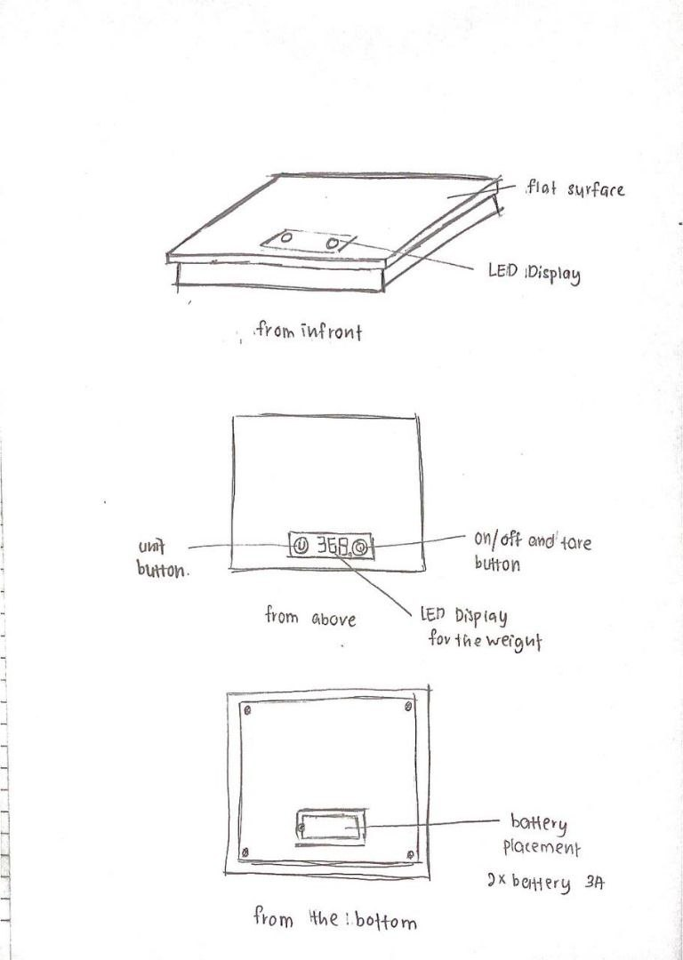

5.4 Prototype Phase

We build a prototype using the material we have to explore their efficiency and viability

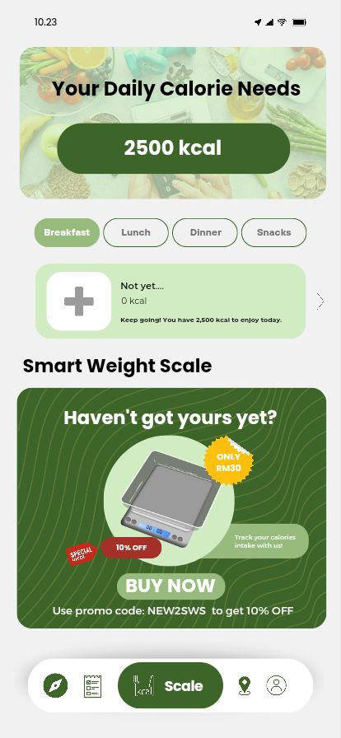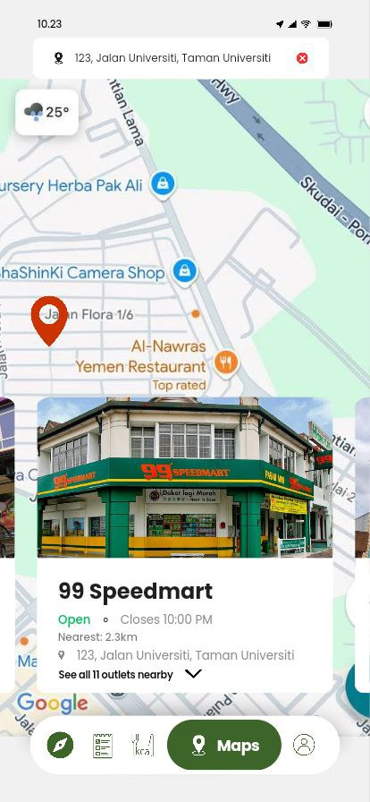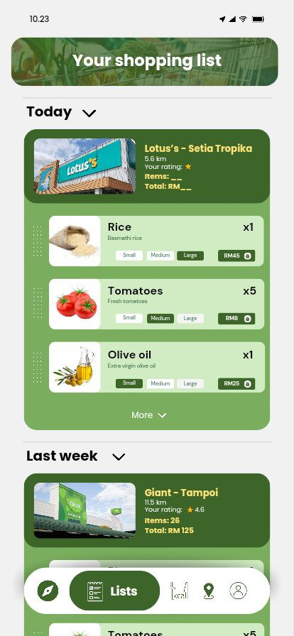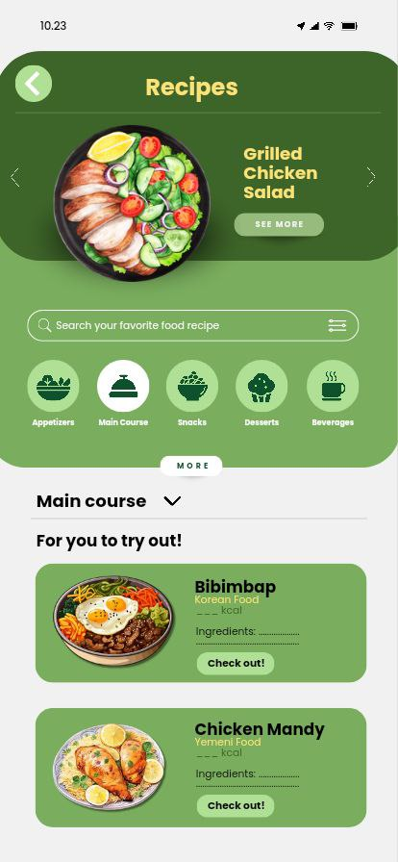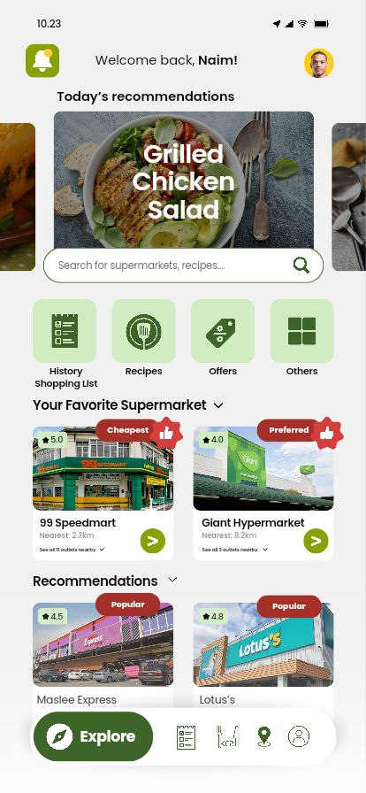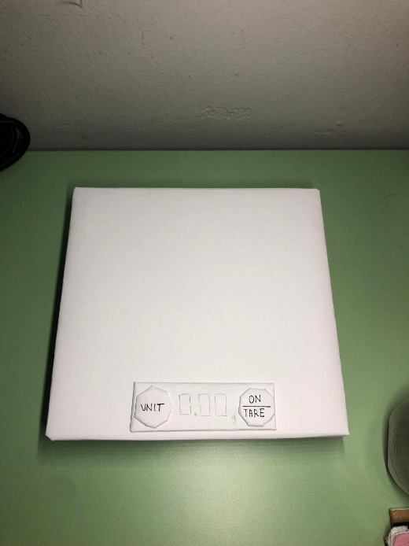

5.5 Testing Phase

We ask several users to test our product to get feedback and accurate data on what to improve**.**

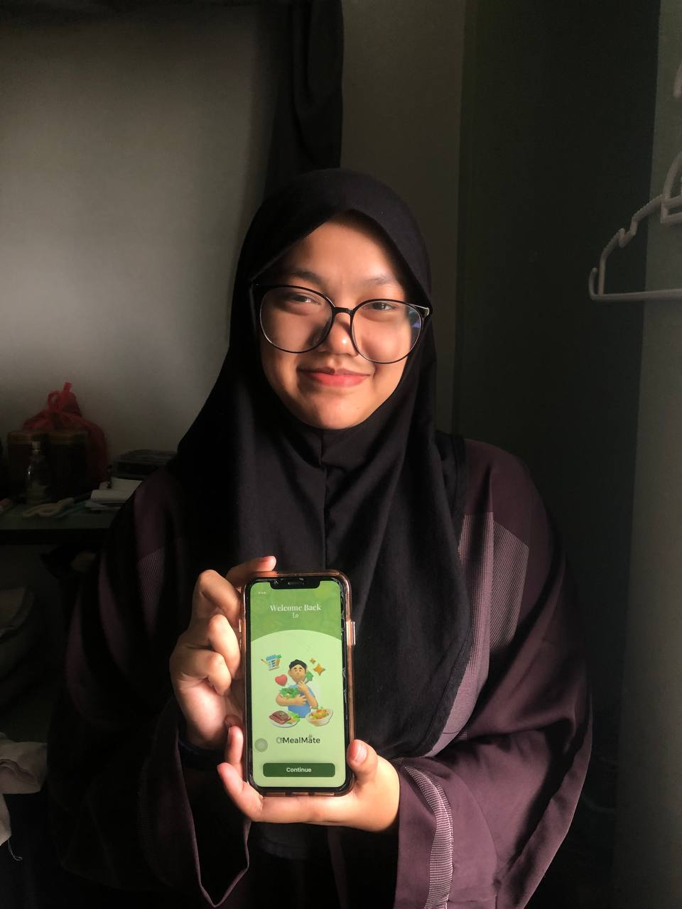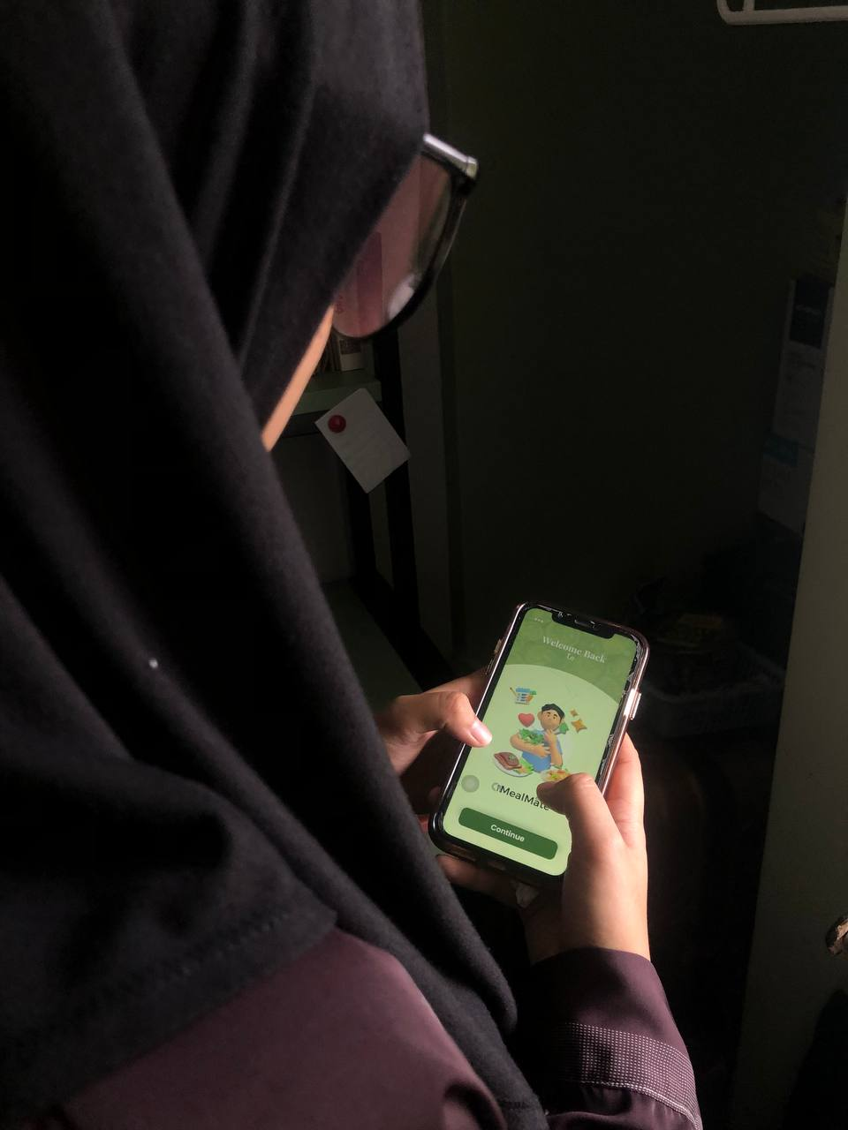

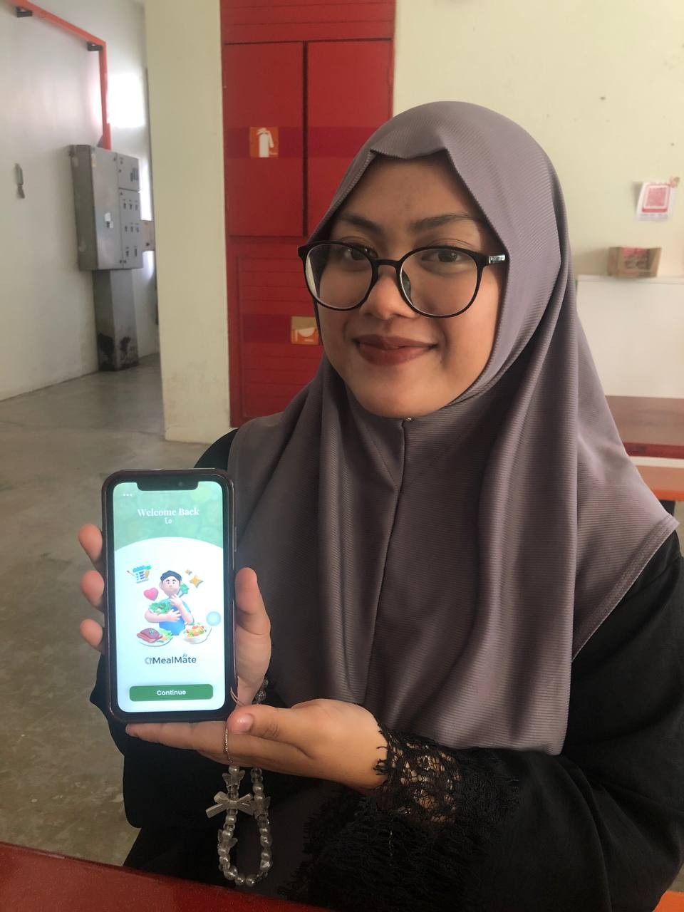

6.0 REFLECTION

1. NURIN HAZWANI BINTI HUSSIN (A24CS0171)

**What is your goal/dream with regard to your course/program?**

My goal is to become skilled in developing AI applications that solve real-world problems and improve people’s daily lives.

**How does this design thinking impact your goal/dream with regard to your program?**

Design thinking helps me approach problems creatively and focus on user needs, which is crucial for developing AI solutions that are both innovative and practical.

**What is the action/improvement/plan necessary for you to improve your potential in the industry?**

I plan to improve my technical skills in AI and app development, enhance my knowledge of user experience (UX) design, stay updated with the latest technology trends, and practice my communication skills.

2. NUR ELISA AFIRA BINTI MOHAMAD NAZIR (A24CS0160)

**What is your goal/dream with regard to your course/program?**

I will improve my knowledge and skill as I plan to become a UI/UX developer at a prominent organization.

**How does this design thinking impact your goal/dream with regard to your program?**

Design thinking taught me how to organize projects and the importance of communication in teamwork. Exchanging ideas makes me realize that I have to think outside of the box to bring creativity and innovative solutions.

**What is the action/improvement/plan necessary for you to improve your potential in the industry?**

In order to improve myself, I plan to join any event or workshop that will help upgrade my skills. I will also improve my communication skills to expand my professional network to help me acquire the best industry best practices.

3. WARDINA SAFIAH BINTI HARUN (A24CS0209)

**What is your goal/dream with regard to your course/program?**

I want to become a skilled UI/UX designer and app developer, creating user-friendly applications that could help everyone’s daily life to be easier and much better. My goal is to integrate AI into app development to improve user experiences.

**How does this design thinking impact your goal/dream with regard to your program?**

This design thinking process has made me realize the importance of user-centered design in creating a functional and visually appealing applications. It has pushed me to think more critically about solving a real problems and refine user experiences.

**What is the action/improvement/plan necessary for you to improve your potential in the industry?**

I plan to enhance my UI/UX design skills and improve my programming knowledge to build a strong portfolio. I will also seek internships in related departments, build strong networks with industry professionals, and stay updated with design trends.

7.0 TASK DISTRIBUTION

|  |  |  |
| --- | --- | --- |
| NO | NAME | TASK |
| 1 | NURIN HAZWANI BINTI HUSSIN (A24CS0171) | * Preparing Video * Sketching Prototype * Preparing Presentation Slide * Make Prototype (Product) |
| 2 | NUR ELISA AFIRA BINTI MOHAMAD NAZIR (A24CS0160) | * Write Full Report * Make Prototype (Product) * Act As Interviewer |
| 3 | WARDINA SAFIAH BINTI HARUN (A24CS0209) | * Sketch App Design * Make Prototype (Apps) * Make Prototype (Product) |